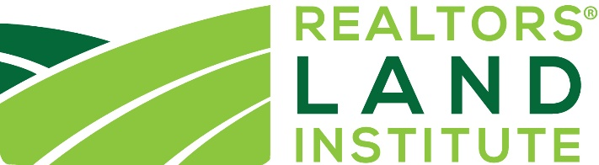

Request for Variance from ALC Designation Criteria
RLI recognizes that land is different across the 50 states and each real estate transaction is unique. As such, it is difficult to create hard rules that apply across the board. This form is to be used before an ALC application is submitted to request a variance in the stated ALC Designation rules and criteria. Please answer the questions as thoroughly as possible and submit to alcapp@rliland.com.

Date of Request:
Name:
Company:
Phone Number:
Email:
- Your request for a variance applies to which ALC Designation rule or criteria?

- Why are you asking for the variance? What is unique about your situation that you need to request a variance?

- What percentage is this type of land/transaction of your overall business?

- Which path are you taking to the ALC? Will you be submitting 25 separate land transactions or submitting at least five closed land transactions with a combined total meeting the minimum volume requirements?

- Please tell the ALC Designation Committee about yourself (your background and your business).

- Is there anything else you would like the committee to know regarding your request for a variance?

